CompTia A+
MODULE: Hardware and Components Basics: Understanding of Hardware and its components
Day 2: Motherboard and CPU Theory
TASKS
1. Draw a labelled diagram of an ATX motherboard and mark at least 8 different slots and ports (such as RAM slots, PCIe slots, SATA ports, USB headers, CPU socket, power connector, etc.).
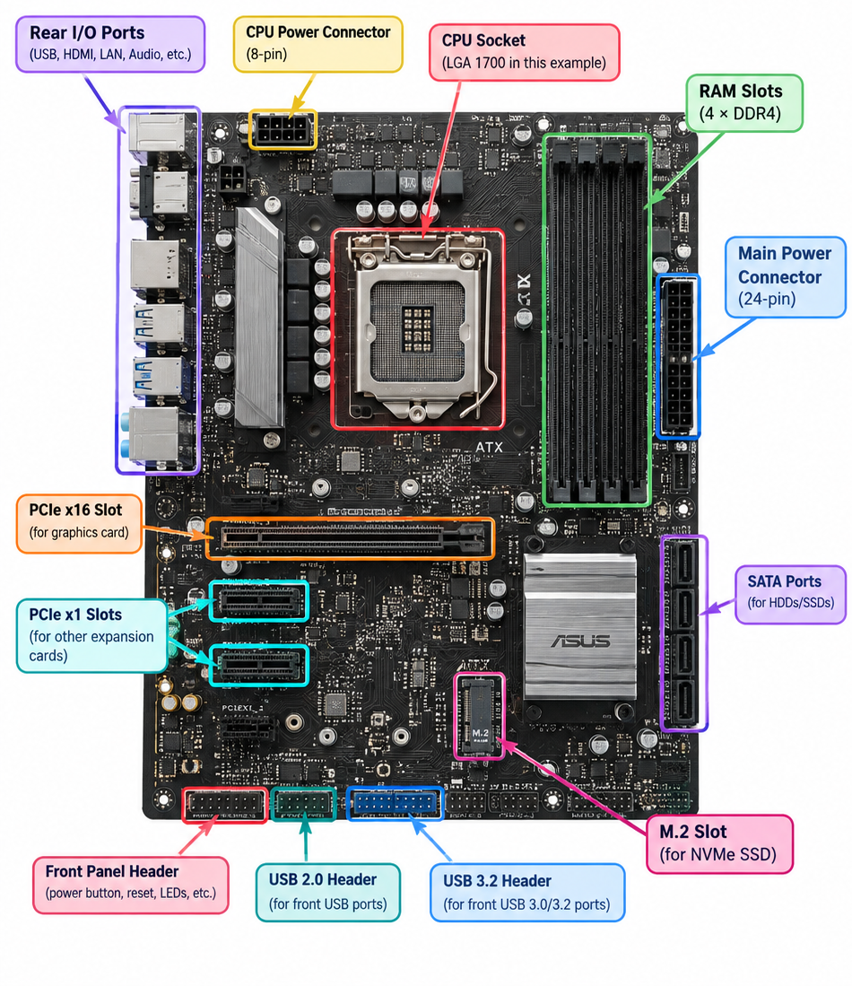
2. Research and list 3 popular CPU socket types (for example: LGA1151, AM4, LGA1200) and name one compatible CPU model for each.
CPU Socket Type | Compatible CPU Model
LGA1151 | Intel Core i7-9700K
AM4 | AMD Ryzen 5 5600
LGA1200 | Intel Core i5-10600K

- LGA1151: Supports Intel 8th and 9th Gen desktop CPUs; the i7-9700K is an LGA1151 processor.
- AM4: AMD Ryzen 5 5600 uses the AM4 socket.
- LGA1200: Intel 10th and 11th Gen desktop processors use LGA1200; the i5-10600K is one example.

3. Explain in your own words the primary functions of the CPU and the chipset on a motherboard, and describe how they work together when you open a music app like Spotify.
CPU and Chipset Functions
CPU (Central Processing Unit):
The CPU is the main processing unit of the computer. It executes instructions, performs calculations, and controls the operations of different programs.
Chipset:
The chipset is a group of motherboard controllers that helps the CPU communicate with other hardware, such as RAM, storage devices, USB devices, and other peripherals.
Example: Opening Spotify
When you open Spotify:
- You click the Spotify icon, and the chipset helps transfer the required data from the storage device to the RAM.
- The CPU processes the instructions needed to start Spotify.
- The chipset helps coordinate communication between the CPU, RAM, storage, network, and other hardware.
- The CPU continues processing Spotify's operations while the hardware components work together.
- The audio data is sent through the system to the audio device/speakers, allowing you to hear the music.

4. Find a clear photo of a real motherboard (from the internet or your own device), and identify at least 5 different ports or slots by circling them and labelling each one.
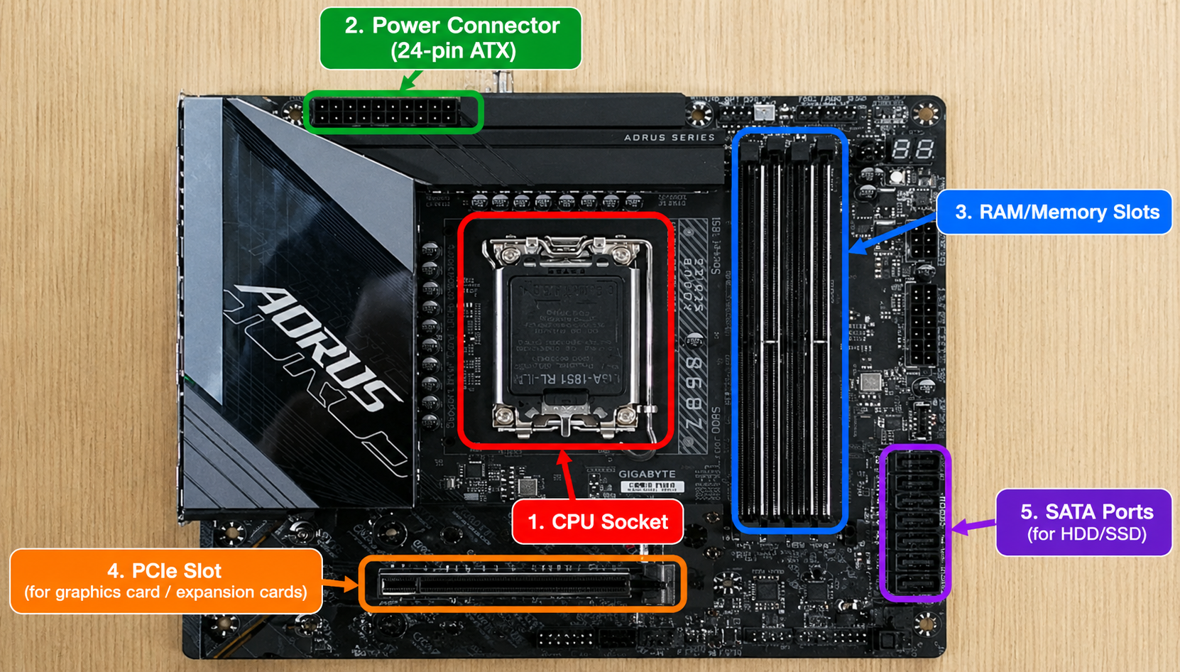
1. CPU Socket – where the processor is installed.
2. RAM/Memory Slots – where RAM modules are inserted.
3. PCIe Slot – used for expansion cards such as a graphics card.
4. SATA Ports – used to connect storage drives such as HDDs/SSDs.
5. Power Connector – supplies power from the PSU to the motherboard.

